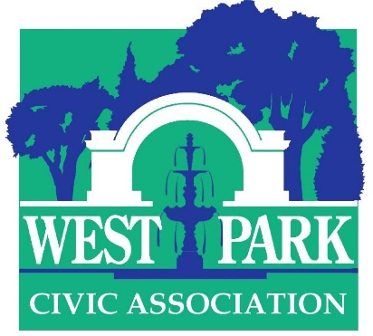
45th Annual Art-in-the Park
Saturday June 15 10 A. M. to 5 P. M. (rain or shine)

Student Application

Application process
Please email six clear color images of examples of the work you propose to exhibit along with your name, mailing address, email address and telephone # to Dr. Christine Isabelle Oaklander at drokie16@gmail.com. If you have a website, please provide the url. Deadline for applications: May 15. Notification: rolling, June 1 at the latest. Your commitment to exhibit must be received by June 7.

Who may apply
College- and high school-level artists (grades 9-12) of high accomplishment are invited to apply. Applications will be vetted by Dr. Margo Hobbs, Associate Professor and Chair of the Art Department, Muhlenberg College and Ilene Hochberg Wood, aesthetic trendsetter and prominent art patron. We seek to provide students with a professional experience in exhibiting, networking, and selling.

Mediums accepted/prizes
Acceptable mediums include sculpture, painting, works on paper (drawings, photographs, collage, prints) and crafts (woodworking, ceramics, fiber art, jewelry etc). Cash prizes will be awarded in separate student categories. Our judges are Dr. Kathleen Jameson, the new Executive Director & CEO, James Michener Art Museum and Scott Schweigert, Curator of Art & Civilization, Reading Public Museum.

Exhibitor information and dates
Two or more exhibitors may share one space through prior arrangement if the exhibitor does not have enough work to fill his/her own space. Display screens consisting of 2 hinged panels (total area 52”x 63”) are available by prior arrangement at time of registration. Limit 2 screens. The artist—or a pre-approved family member/friend—must be present to sell and interact with the public and judges; you may bring an assistant to help with your booth.

Sales
Exhibitors are permitted to sell their works; no commission will be charged. However, you are responsible for all transactions and the WPCA cannot make change or facilitate the sale. The show will be promoted through online and press media. A program listing exhibitors will be distributed on the day of the show. Please email Dr. Christine Isabelle Oaklander at drokie16@gmail.com with any questions.

