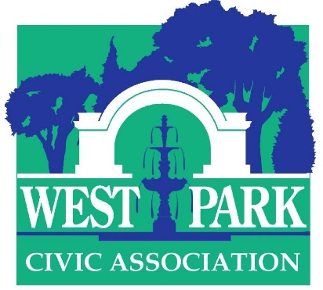

46th Annual Art-in-the Park
Saturday September 18, 2021 10 A. M. to 5 P. M. (rain or shine)

Student Application
Process
Please email clear color images of six examples of your art along with your name, mailing address, email address and telephone # to Dr. Christine Isabelle Oaklander at drokie16@gmail.com. Deadline for applications: August 15. Notification: rolling admissions, latest notification August 31. Your commitment to exhibit must be received by September 7.

Who may apply
College- and high school artists (grades 9-12) of accomplishment are invited to apply. Applicants will be vetted by Ward Van Haute, director of Bethlehem House Gallery and Diane LaBelle, former director of the GoggleWorks and CEO (retired) of the Lehigh Valley Charter High School for the Arts. We provide students with a professional experience in exhibiting, networking, and selling.

Mediums accepted/prizes
Acceptable mediums include sculpture, painting, works on paper (drawings, photographs, collage, prints) and crafts (woodworking, ceramics, fiber art, jewelry etc). Cash prizes will be awarded in separate student categories. Prize judges will be Prof Curlee Raven Holton, master printmaker and Executive Director, David Driskell Center, University of Maryland College Park and Dr. William B. Crow, Executive Director, Lehigh University Art Galleries. Art must be original; no exhibitor will be allowed to sell a majority of reproductions, including giclees/greeting cards/T-shirts and similar.

Exhibitor information and dates
Two or more exhibitors may share one space through prior arrangement. Display screens consisting of 2 hinged panels (total area 52” x 63”) are available on request at time of registration. Limit 2 screens. The artist—or a pre-approved family member/friend—must be present to sell and interact with the public and judges; you may bring an assistant to help with your booth.

Sales
Exhibitors are permitted to sell their works with no commission. You are responsible for all transactions and the WPCA cannot make change or facilitate the sale. The show will be promoted through online and press media. A booklet with a list and map of exhibitors will be distributed at the show.

Covid-19 protocol as set forth by the State of Pennsylvania will be followed during the event.

