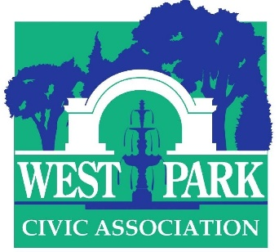

46th Annual Art-in-the-Park
Saturday September 18, 2021 10 A.M. to 5 P.M. (rain or shine)

Application

Application process
Please email low- or medium-resolution color images of six artworks along with your name, address, and telephone # to Dr. Christine Isabelle Oaklander at drokie16@gmail.com. Deadline for applications: August 15. Notification: rolling admissions, latest notification August 31. Your commitment to exhibit must be received by September 7.

Who may apply
Accomplished, original artists from all ages and backgrounds (trained and untrained) are encouraged to apply. Adult and student applicants will be vetted by Ward Van Haute, director of Bethlehem House Gallery and Diane LaBelle, former director of the GoggleWorks Center for the Arts and CEO (retired) of the Lehigh Valley Charter High School for the Arts. There is no application fee.

Mediums accepted/Prizes
Acceptable mediums include sculpture, painting, works on paper (drawings, photographs, collage, prints) and crafts (woodworking, ceramics, fiber art, jewelry etc.). Art must be original; no exhibitor will be allowed to sell a majority of reproductions, including giclees/greeting cards/T-shirts and similar. Cash prizes will be awarded in various categories. Prize judges will be Prof Curlee Raven Holton, master printmaker and Executive Director, David Driskell Center, University of Maryland College Park and Dr. William B. Crow, Executive Director, Lehigh University Art Galleries.

Hors Concours
Artists who have exhibited the past two years are deemed Hors Concours, meaning that they are automatically accepted and do not have to undergo the vetting process. If you have any questions about whether you qualify for Hors Concours, just ask.

Exhibitor fees, dates, and other information
An exhibitor fee of $65 for a 25-foot space is due by September 10, 2021. If you have a favorite spot, please let us know. No commercial galleries or representatives are permitted. The artist must accompany his/her exhibit—or arrange for a pre-approved substitute—to interact with the public. Two or more exhibitors may share a space by pre-arrangement, but the entry fee must be paid by each exhibitor. Display screens consisting of 2 hinged panels (total area 52” x 63”) are available first-come first-served for a fee of $10 each; limit 3 screens. Refunds will only be given if the show is cancelled. Please send checks for entry fee and screens made out to West Park Civic Association, noting in the memo section that the payment is for Art-in-the-Park. Mailing address: 19 S. Franklin Street, Allentown, PA 18102 Attention: AITP

Sales
Exhibitors are permitted to sell their works; there is no commission. However, you are responsible for all transactions; the WPCA cannot make change or facilitate sales. The show will be promoted vigorously through online and press media. A booklet with a map and list of exhibitors will be distributed on show day.

Covid-19 protocol as set forth by the State of Pennsylvania will be followed during the event.

